**Management of workers**

**The unicity of each worker is done by is Badge Number**, which is a mandatory field in the creation of the worker.

When a worker is created by an Owner Contract Admin, the worker is associated with the company that owns the contract on which he is created and is also associated on the contract on which he is created.

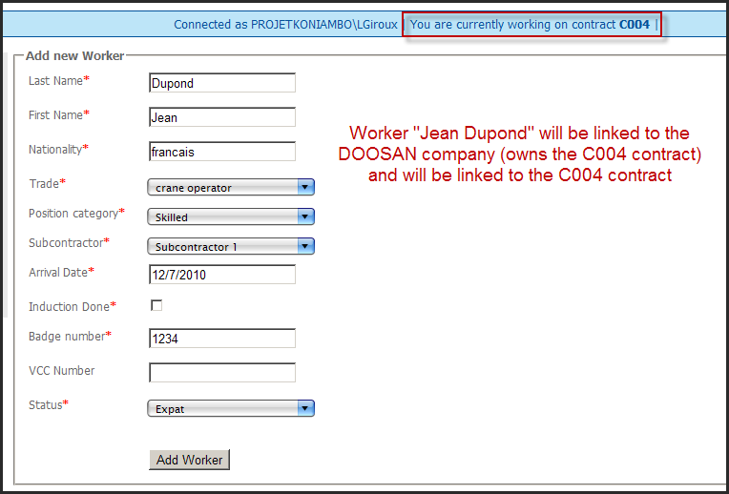

If a Contract Admin of another contract on the same company also wants to add this worker, he will have to do as following:

* Select the worker in the list of workers **that belong to the company which own the contract**.
* Define the trade and the position category of the worker.

**Important**:

The definition of a trade and a position category for a worker is made at the contract level.

That means that a same worker can be for example a welder on the contract CXXX of the DOOSAN company and also be a crane operator on the contract CYYY of the DOOSAN company ( same logic for the position category).

That also means that every trade/positionCategory edition on a worker made by a contract administrator on his contract will no affect the trade/positionCategory of this specific worker on another contract.

**By doing this, we ensure the data integrity (a worker is defined only 1 time in the database),we can make the hours checks on multiples contracts and we ensure that each contract works independently and has no effect on others contracts**.

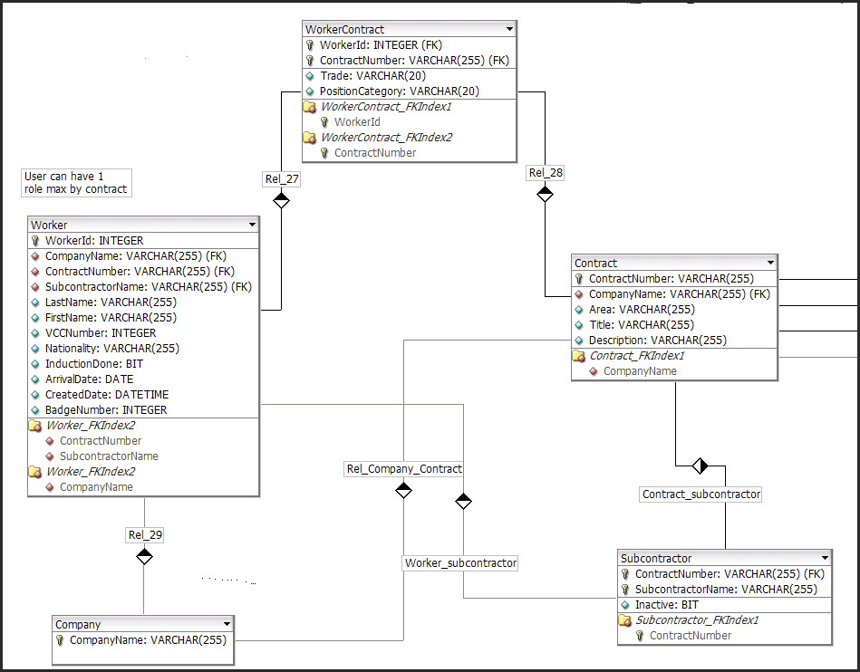

DB model